Student’s name | …………………………………………………….…… | Grade | 6
Subject | Computer | Week No. | 9
Lesson Title | Cyber Security | Unit
Worksheet No. ( 9 )

Question A: write the correct name of each part.

User | Man in the Middle | Web Applications
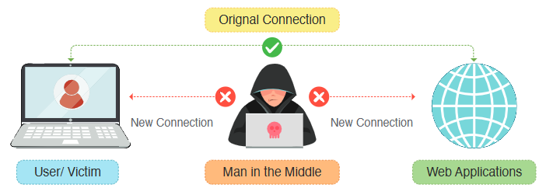
………………
………………
………………
Good Luck

